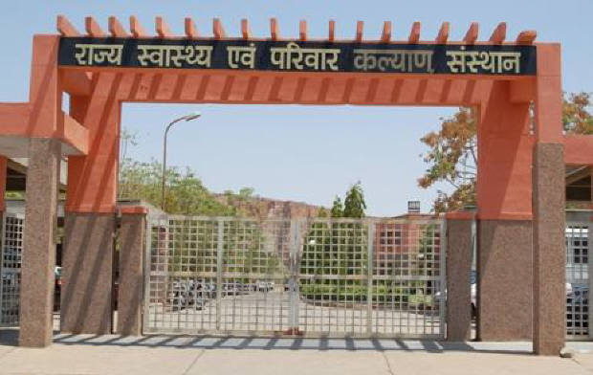

**SIHFW Rajasthan**

***Electronic Newsletter***

***April to June 2025*  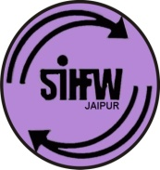**

SIHFW: an ISO 9001:2015 certified Institution

**From the Director’s desk…**

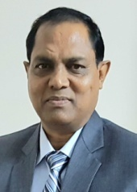

*Dear Friends…*

*This issue of e newsletter is being release at the time of welcoming monsoons. Which bring joy to some parts of the world and bring grief for some with devastating floods following heavy rainfalls. Climate change is vibrantly visible and calls for action. With such challenges in difficult to reach areas, participants manage to reach training venue, be it State, District or Block Headquarters. This issue of e-newsletter provides information on trainings and related activities organised during past quarter of April to June 2025.*

*We request all readers to kindly pour us with your feedbacks and suggestions to make this institute a better one and also for this e newsletter. We would solicit your feedback and suggestions.*

*Best Wishes!!*

*Dr. S.S. Agrawal*

*Director-SIHFW*

|  |  |
| --- | --- |
| *Some important health and social days for April to June 2025* | |
| World Autism Awareness Day –April 2, 2025 | World Hand Hygiene Day, May 5, 2025 |
| World Health Day-April 7, 2025 | World Asthma Day May 7, 2025 (first Tuesday of May) |
| World Parkinson Day-April 11, 2025 | World Thalassemia Day May 8, 20252024 |
| National Safe Motherhood Day-April 11, 2025 | Anti-tobacco Day May 31, 2025 |
| World Hemophilia Day-April 17, 2025 | International Day for Action of Women’s Health May 28, 2025 |
| Earth Day-April 22, 2025 | World Environment Day June 5, 2025 |
| World Malaria Day-April 25, 2025 | International Day of Yoga, June 21, 2025 |
| World Day for Safety and Health at Work-April 28, 2025 | International Day against Drug Abuse and Illegal Trafficking June 26, 2025 |

**International Day of Yoga, June 21, 2025 at SIHFW**

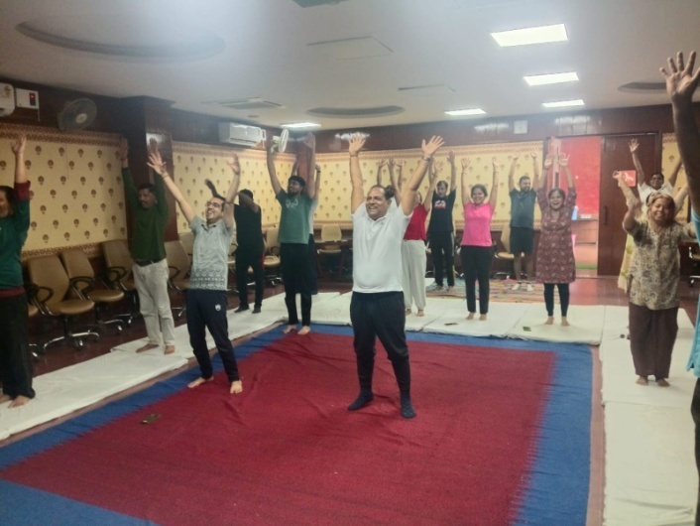The International Day of Yoga is a recognition of Yoga, it is celebrated across the world annually on June 21. It has also been recognized by the United Nations in 2014. Yoga has shown significant benefits for physical and mental well being. It was considered important by the UN globally and therefore it was promoted as a wellness practice, which originated in ancient India.

SIHFW staff also did Yoga early morning at SIHFW campus.

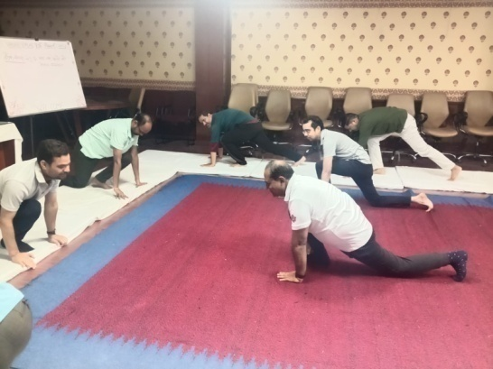

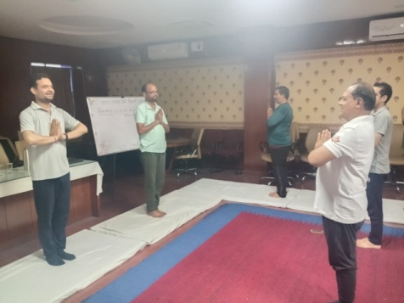

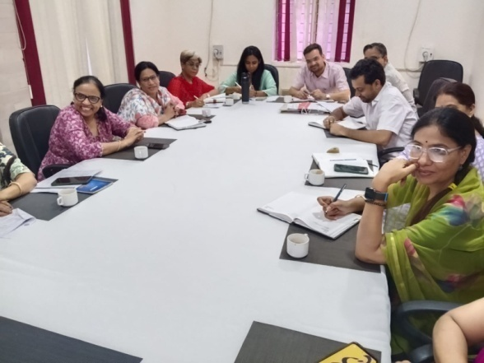**SIHFW Staff Meetings**

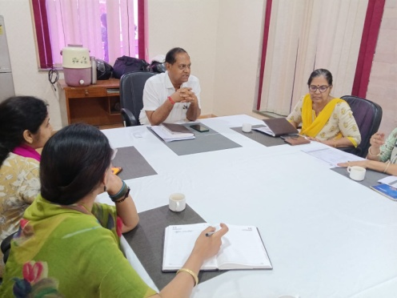Staff Meetings was organised at SIHFW under chairmanship of Director SIHFW. These meetings are organised to review training progress and give quality inputs in planning of all trainings in the State. First meeting of this quarter was organised on April 15, 2025. These meetings also provide opportunity for all coordinators for cross learning from each other.

**Workshops at SIHFW**

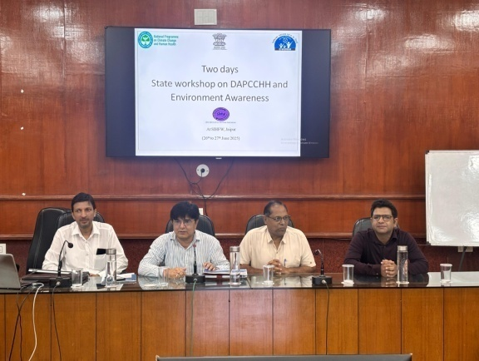**Orientation Workshop under National Program for Climate Change and Human Health (NPCCHH)**

This was a 2 days workshop organised at SIHFW on June 26-27, 2025. Main components of this workshop included Impact of air pollution on human health, disaster management, Lead poisoning scenario, challenges and way forward. During this workshop participants were oriented on District Action Plan on Climate Change and Human Health. There were presentations on Model District Action Plan by districts. Workshop also has discussions on the success stories of Heat wave preparation and management. Roles and responsibilities of Deputy CMHO (Health) were also discussed. 39 participants were trained in this training.

**Health Labour Market Analysis-**

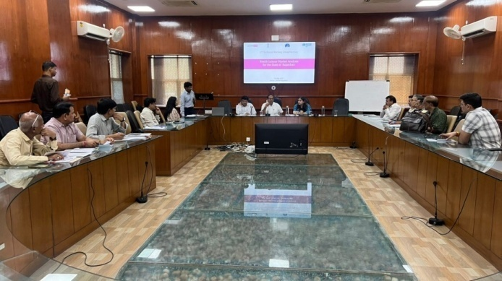

**Trainings at SIHFW**

**Training of Trainers (ToT)**

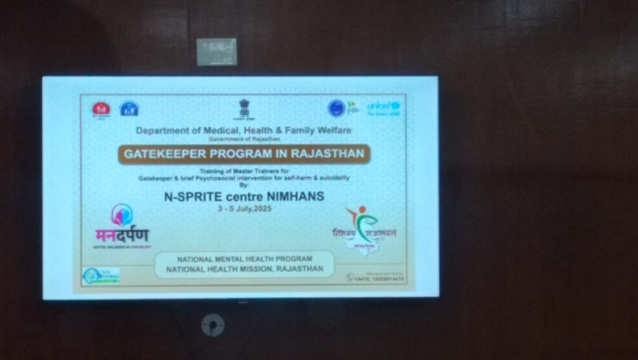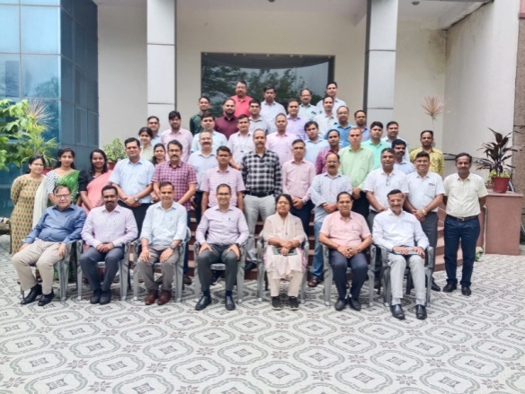**Gatekeeper Program**

This is a new initiative ToT for Master Trainers under Gatekeeper and brief Psychological interventions for self-harm and suicidality. It was jointly organised by N-SPRITE centre of NIMHANS and NHM Rajasthan, under NMHP. It is of 3 days and psychiatrists 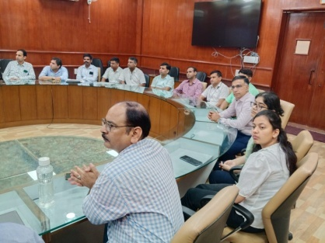participated in this ToT. Objective of this program is promoting mental well-being, Mental Health Week activities/ psycho-social intervention for self-harm and suicidality. Under UNICEF partnership 1 state level Master Trainers ToT batch was organised at SIHFW and 43 participants were trained. Later under NHM PIP one batch of State level ToT on Gatekeepers was also organised and 50 participants were trained.

**State level Orientation on positive mental well being**

This is a 5 days orientation on NMHP and DMHP organised for Medical Officers at SIHFW. Key objectives of this training is to orient MOs on Understanding Mental Health, Identification, management and treatment of various Neurosis and Psychosis, non-pharmacological intervention. During last 3 months 3 batches were organised and 131 participants were trained in these batches.

**ToT Dakshata**

This is a 5 days ToT organised at SIHFW. Participants include labour room Staff –SN & Teaching staff -PHN, NT. Key training components include Internatal care, post natal car, hands on practice is done in labour room at Skill Lab at SIHFW. Training methodology is classroom sessions and hands on Practice in skill lab. Trained participants will provide Dakshata Training in District after completing this ToT. During last 3 months one batch was organised, 22 participants were trained in this training.

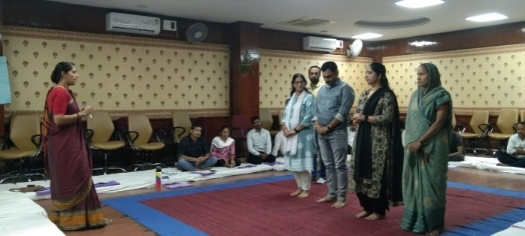**Trainings on PLA**

**ToT on PLA**

This ToT is organised on Participatory Learning in Action (PLA). This batch was initially organised for 5 districts- Baran, Banswara, Dungarpura, Udaipur and Pratapgarh. Now from this financial year 5 more districts have been added. These are Ajmer, Chitorgah, Jhalawar, Pali ad Rajsamand. Participants include BHS and PHS.

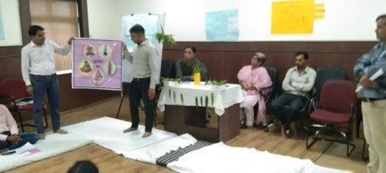This training is organised at SIHFW with technical support of Ekjut. Sitting arrangement for this training is done on floor with dari and mattresses because this training has relevance with village level field work. Participants of this training will work with staff and community for developing village social maps of available resources and develop village plans with community involvement. Participants will organize PLA sessions at field level involving community members and field functionaries.

Role plays are organised on VHSNC meetings and Community Meetings. These dummy meetings are organised on various themes such as PLA, Identification of problems and preparing strategies, Family Planning, Safe Abortion, Nutrition, etc.

In State ToT, 1 batch was organised at SIHFW and 10 participants were trained as Master Trainers.

These ToT trainings are also organised at districts, coordinated by SIHFW. 14 batches were organised at during past three months and 28 participants are trained.

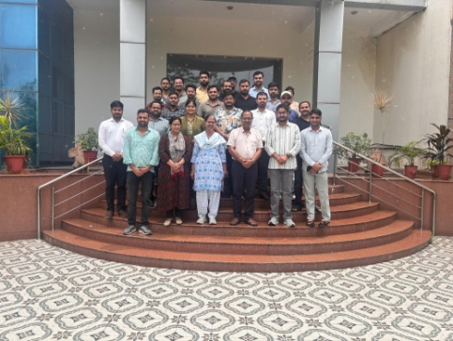**Foundation training of Newly Recruited Medical Officers**

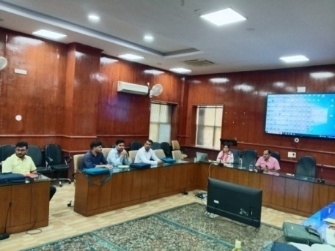This is a 12 day training provided to newly recruited Medical Officers. Objective of this training is to orient the newly recruited MOs to learn about the various health programmes and schemes, latest guidelines, Acts, rules and regulations and government procedures, which they have to perform as a Medical officer. The training focuses on sharpening administrative skills of MOs along with clinical roles and responsibilities.

Participants were also taken on field visits to observe UPHC Gandhinagar for Quality Assessment and Certification Process. Participants are given hands on exposure in skill lab of SIHFW on various work stations and with dummies. During last 3 months, 2 batches of Foundation training were organised and 44 newly recruited Medical officers were trained in this training.

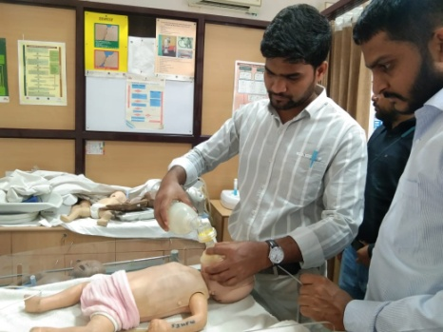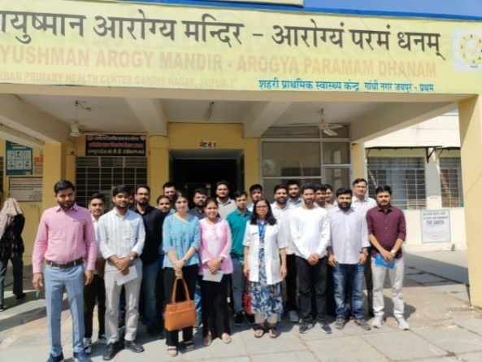

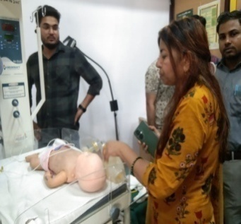

**STLS/PPM training**

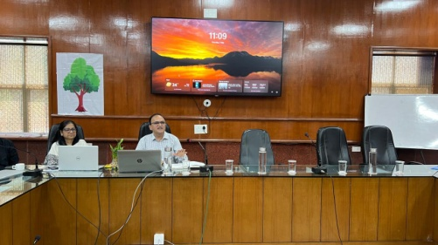

May 1-2, 2025

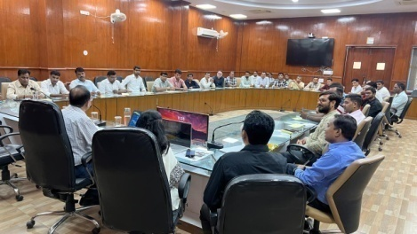

**Training on Community Action for Health**

During last three months 2 batches of CAH training were organised at SIHFW. 49 participants were trained in this training. DPO and DPCs participate in this training.

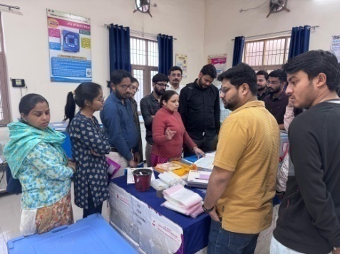**Training under National Rabies Control Program**

This is a one day training for orientation on National Rabies Control Program. 61 participants were trained in this training. Deputy CMHO –Health and District In charges participate in this training.

**Trainings under Immunization Program**

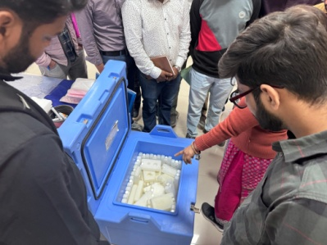**Routine Immunization Training for Medical Officers**

Routine Immunization training is of 3 days duration organized for Medical Officers at SIHFW. Training batches always scheduled such that first day of training is on Tuesday so that participants get an exposure visit of Routine Immunization session planned on Thursdays (MCHN day). Immunization schedule, AEFI, Cold chain, Vaccine Management etc are the components of this training. 8 batches have been organized at SIHFW during last three months and 122 Medical Officers were trained.

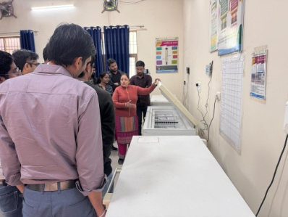**Orientation for BCMOs**

Two days training –Orientation on Cold Chain for Block level Officials is organized at SIHFW. BCMOs and Medical Officers participate in this training. During last 3 months 2 batches were organised and 49 participants were trained in this training.

**Leprosy**

Training of trainers on Leprosy was organised at SIHFW and 77 participants were trained in this ToT and 2 batches of LCDC were organised and 119 participants were trained in this training.

**Trainings under NVBDCP**

**Malaria Microscopy**

6 batches of Malaria microscopy training were organized at SIHFW in last financial year. In this 5 days training for Lab assistants and Lab technicians are trained in these trainings. 147 participants were trained in these trainings.

**Training on Dengue and Chikunguniya**

2 batches of this training were organised for Medical Officers at SIHFW and 45 participants were trained.

**Training on Alpha Spray**

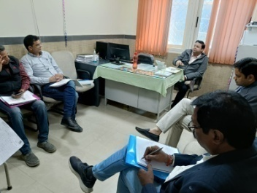This training was organised as a part of ICMR collaboration study on evaluation of the diagnostic accuracy in private clinics and diagnostics-a cross sectional study. 2 batches were organised during last 3 months and 51 participants were trained in these batches.

**NPPC Training**

Training on Palliative care is organised at SIHFW and exposure visits are arranged at Centre for Palliative Medicine and care at SMS Hospital, Jaipur. This training is of two categories-3 days training for Medical Officers and 6 days training for Nursing Officers. 2 batches are completed for Medical Officers and 21 participants were trained and 1 batch is completed for Nursing Officers and 7 participants were trained. In NOs training, online sessions were done on coordination with AIIMS, Jodhpur and hands-on sessions were organised at SMS, Jaipur.

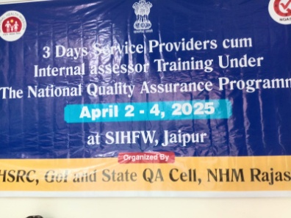

**Deafness training for Medical Officers**

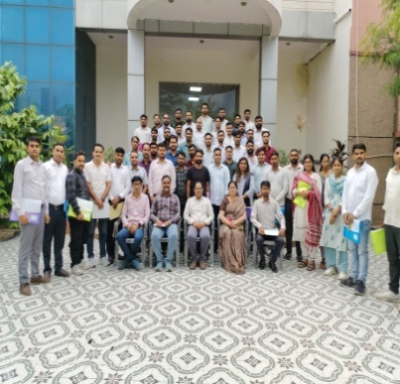Screening training for deafness was organised at SIHFW for Medical Officers. 1 batch was organised and 39 Medical Officers were trained in this training.

**Service Providers Training on National Quality Assurance Program (NQAS)**

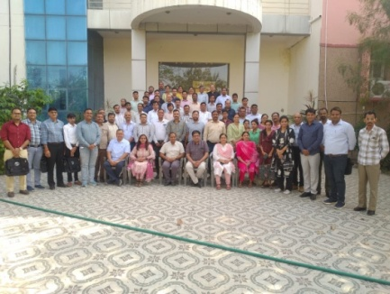This is a 3- days training of service providers on National Quality Assurance Program, organised at SIHFW. Assessors, trainers participate at this training. This training is organized to develop knowledge of quality standards and assessments formats.

**ASHA Refresher ToT training**

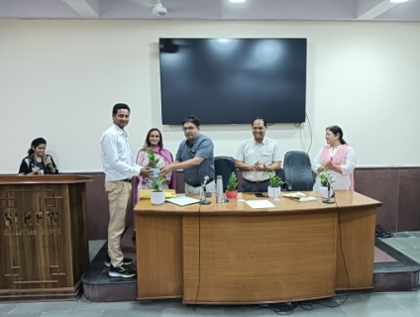

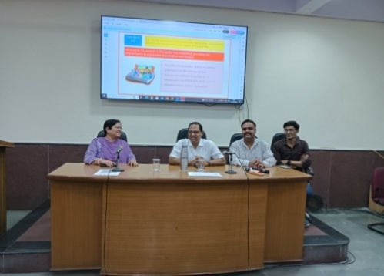ASHA Refresher ToT trainingis organized under ASHA Program. This is a six day training organized for refreshing knowledge of District ASHA trainers and mentoring and facilitation staff including ANM/SHS, etc. This training develops better supervision skills in facilitators to provide hand holding for ASHA workers. During last financial year 2 batches were organised and 35 participants were trained.

**Training of Dental MO under NOHP**

This is a one day training of Dental Medical Officers under National Oral Health Program. This training is organized at SIHFW. 1 batch was organized and 64 participants were trained in these two batches.

**Field Trainings organized by SIHFW**

**Comprehensive Abortion Care (CAC)**

Training on Comprehensive Abortion Care (CAC) is organised at District or equivalent hospitals, for 12 days. During last 3 months, 8 batches of CAC training were organised and 31 participants were trained.

This is a complete hands-on training.

**Medical Method of Abortion (MMA) Training**

This is a clinical training organized at District Hospitals for Medical Officers. 7 batches have been completed in last financial year. MMA training was organized at Medical College level by SIHFW. 14 participants were trained in this training.

**RI for HW**

Routine Immunization training for Health workers is of 2 days duration and is organized at Districts for Health workers-ANM, GNM, LHV and Nursing staff. Participants are oriented on Routine Immunization schedule, AEFI, cold chain management, vaccine storage and micro planning of routine immunization, social mobilization and reporting mechanism.

**Regular Sessions on Organ Donation at SIHFW**

Sessions on Organ Donation are being organised at SIHFW in every training batch. Participants are oriented about the organ donation, legal provisions and clinical conditions for organ donation and procedure for registration. Sessions are delivered by experts from Mohan Foundation (NGO specialising in work of organ donation).

***Thoughts to Ponder…***

This is a column that belongs to SIHFW staff, where they will be sharing a direct dialogue with readers of this newsletter. They will share their experiences and thoughts which may be relevant to your life and let’s see how we all can learn from each other’s experiences and grow with each other. It is an open letter to all of you.

*Dear Readers*

*I am sharing my experience and knowledge on a very important subject i.e. ‘Osteoporosis in women’.*

*At an early age of only 55 years I have had to get my knee replacement done, my surgery and healing process gave me a deeper insight into life that I would like to share with you all:*

* *Osteoporosis in young women in India is a growing concern. Several factors contribute to this-*
* *Low calcium intake-Dietary deficiency specially during adolescence, pregnancy and lactation.*
* *Vitamin D deficiency –limited sun exposure due to sunscreens and inadequate dietary intake f Vitamin D*
* *Sedentary Lifestyle-Urban women, specially those in sitting jobs and more helping hands at home,*
* *Smoking and alcohol consumption-becoming prevalent in young women in India*
* *Genetic and ethical factors-family history makes more susceptible*
* *Early Menopause-Indian women attain menopause earlier than Caucasian women.*

*To prevent Osteoporosis women should take calcium rich diet as dairy and fortified foods. Take professional healthcare advice and start supplements to ensure adequate intake.*

*To maintain a healthy lifestyle early in life as in adolescence and do regular Yoga and exercise and avoid smoking and alcohol consumption in excess.*

*Managing stress is most important, but unfortunately even after knowledge through all sources common in current time, still women neglect their health and land up with early depletion of calcium.*

*Remember friends- Strong Bones-Strong Minds-Strong Women-Strong Nation.*

*-Dr Bharti Sharma, Faculty, SIHFW*

**Welcoming the Interns!**

Under SIHFW Internship Programme, this session SIHFW has welcomed four Students doing graduation course at from Department of Extension Education and Communication Management, College of Community Sciences, Swami Kesawanand Agriculture University, Bikaner. Students Ms. Ritu, Ms. Yogita, Mr. Dushyant and Mr. Manish have joined this Internship on July 3, 2025.

This internship is of three months duration and is a part of their curriculum under their course. The interns are being oriented about various programmes and developed presentations, reference materials, review articles and posters on many contents of Public health and programmes / schemes under NHM. They have also been given assignments. Interns are also participating in trainings at SIHFW and are going to field visits schedules in various trainings.

**Health News**

# Tobacco control efforts protect 6.1 billion people – WHO’s new report

The World Health Organization (WHO) released its report on the [Global Tobacco Epidemic 2025](https://www.who.int/publications/i/item/9789240112063) at the [World Conference on Tobacco Control](https://www.worldtobaccocontrol.org/) in Dublin, warning that action is needed to maintain and accelerate progress in tobacco control as rising industry interference challenges tobacco policies and control efforts. The report focuses on the six proven [WHO MPOWER tobacco control measures](https://www.who.int/initiatives/mpower) to reduce tobacco use, which claims over 7 million lives a year:

* **M**onitoring tobacco use and prevention policies;
* **P**rotecting people from tobacco smoke with smoke-free air legislation;
* **O**ffering help to quit tobacco use;
* **W**arning about the dangers of tobacco with pack labels and mass media;
* **E**nforcing bans on tobacco advertising, promotion and sponsorship; and
* **R**aising taxes on tobacco.

Since 2007, 155 countries have implemented at least one of the WHO MPOWER tobacco control measures to reduce tobacco use at best-practice level. Today, over 6.1 billion people, three-quarters of the world’s population, are protected by at least one such policy, compared to just 1 billion in 2007. Four countries have implemented the full MPOWER package: Brazil, Mauritius, the Netherlands (Kingdom of the), and Türkiye. Seven countries are just one measure away from achieving the full implementation of the MPOWER package, signifying the highest level of tobacco control, including Ethiopia, Ireland, Jordan, Mexico, New Zealand, Slovenia and Spain. However, there are major gaps. Forty countries still have no MPOWER measure at best-practice level and more than 30 countries allow cigarette sales without mandatory health warnings.

The WHO Global Tobacco Epidemic 2025 report, developed with support from Bloomberg Philanthropies, was launched during the 2025 Bloomberg Philanthropies Awards for Global Tobacco Control. The awards celebrated several governments and nongovernmental organizations (NGOs) making progress to reduce tobacco use. The report reveals that the most striking gains have been in graphic health warnings, one of the key measures under the WHO Framework Convention on Tobacco Control (FCTC), that make the harms of tobacco impossible to ignore:

* 110 countries now require them – up from just 9 in 2007 – protecting 62% of the global population; and
* 25 countries have adopted plain packaging.

WHO warns, however, that enforcement is inconsistent, and smokeless tobacco packaging remains poorly regulated. The new report is accompanied by a [new data portal](https://mpowerportal.org/) that tracks country-by-country progress between 2007–2025. Despite their effectiveness, 110 countries haven’t run anti-tobacco campaigns since 2022. However, 36% of the global population now lives in countries that have run best-practice campaigns, up from just 19% in 2022. WHO urges countries to invest in message-tested and evaluated campaigns. Taxes, quit services and advertising bans have been expanding, but many improvements are needed:

* Taxation: 134 countries have failed to make cigarettes less affordable. Since 2022, just 3 have increased taxes to the best-practice level.
* Cessation: Only 33% of people globally have access to cost-covered quit services.
* Advertising bans: Best-practice bans exist in 68 countries, covering over 25% of the global population.

Around 1.3 million people die from second-hand smoke every year. Today, 79 countries have implemented comprehensive smoke-free environments, covering one-third of the world’s population. Since 2022, six additional countries (Cook Islands, Indonesia, Malaysia, Sierra Leone, Slovenia and Uzbekistan) have adopted strong smoke-free laws, despite industry resistance, particularly in hospitality venues.

There has been a growing trend to regulate the use of e-cigarettes or ENDS – Electronic Nicotine Delivery Systems. The number of countries regulating or banning ENDS has grown from 122 in 2022 to 133 in 2024, a clear signal of increased attention to these products. However, over 60 countries still lack any regulations on ENDS. WHO is calling for urgent action in areas where momentum is lagging. “Governments must act boldly to close remaining gaps, strengthen enforcement, and invest in the proven tools that save lives. WHO calls on all countries to accelerate progress on MPOWER and ensure that no one is left behind in the fight against tobacco,” said Dr Ruediger Krech, Director of Health Promotion. Source: WHO News Release, June 23, 2025

# WHO calls for global expansion of midwifery models of care

The World Health Organization (WHO) released [new guidance](https://iris.who.int/handle/10665/381641) to help countries adopt and expand midwifery models of care - where midwives serve as the main care provider for women and babies throughout pregnancy, childbirth, and the postnatal period.

The guidance promotes strong communication and partnership between women and midwives, and offers proven health benefits for both women and their babies. Women who received care from trusted midwives are [statistically more likely](https://pubmed.ncbi.nlm.nih.gov/27121907/) to experience healthy vaginal births and report higher satisfaction with the services they receive. The guidance states that these approaches improve outcomes, maximize resources, and can be adapted to all countries and they also enhance women’s and families’ experiences of care– building trusted partnerships for health at this critical life stage.

## A proven, cost-effective solution: Despite progress, [maternal](https://www.who.int/news/item/07-04-2025-aid-cuts-threaten-fragile-progress-in-ending-maternal-deaths-un-agencies-warn) and [newborn deaths](https://www.who.int/news/item/30-05-2024-countries-commit-to-recover-lost-progress-in-maternal--newborn---child-survival) remain unacceptably high—particularly in low-income and fragile settings. [Recent modelling](https://cdn.who.int/media/docs/default-source/mca-documents/maternal-nb/midwifery/potential-impact-of-midwives.pdf?sfvrsn=7fccdf3b_5) suggests that universal access to skilled midwives could prevent over 60% of these deaths, amounting to 4.3 million lives saved annually by 2035.

Midwifery care models emphasize informed choice as well as communication and non-invasive techniques—such as mobility during labour, breathing guidance, varied birthing positions and emotional support— that seek to empower women, and reduce the likelihood of invasive procedures.

Midwifery models of care are also an important response to the growing concern of over-medicalization in childbirth. While medical interventions such as caesarean sections, inductions, and use of forceps are essential and life-saving when clinically indicated, their routine or excessive use creates short and long-term health risks. In some countries, caesarean rates now exceed 50%, suggesting high rates of medically unnecessary procedures.

“Skilled midwives help women trust in their bodies, their abilities, and their care,” said Ulrika Rehnstrom Loi, Midwifery expert at WHO and technical lead for the guidance. “This is why investing in midwifery models of care is so important – it not only improves health but builds a cadre of experts equipped to provide individualized, respectful care, ensuring women are consistently part of decision making and have access to the information they need as well as vital emotional support.”

## Practical tools for implementation: The new guidance provides practical tools and real-life examples to help countries structure a transition toward midwifery models of care. As part of this process, it calls for strong political commitment, strategic planning and long-term financing for implementation -- with dedicated budget lines. It also stresses the importance of high-quality midwifery regulation and education in line with international standards, supporting autonomous, evidence-based practice.

Successful implementation requires strong collaboration, the guidance notes. Midwives should be empowered to work independently while also integrated into broader healthcare teams alongside doctors and nurses. In the event of complications, midwives should be able to work in partnership with these other professionals to ensure quality multidisciplinary care for every woman and baby.

## A global imperative: Globally, millions of women still give birth without a skilled health worker by their side, and one-third do not receive even four of WHO’s recommended eight pregnancy checks. Progress in reducing maternal and newborn mortality has [largely stagnated](https://www.who.int/news/item/07-04-2025-aid-cuts-threaten-fragile-progress-in-ending-maternal-deaths-un-agencies-warn) since 2016.

“Midwifery models of care are not just smart solutions - they are a necessity,” said Anna Ugglas, Chief Executive of the International Confederation of Midwives, which supported the development of the guidance. “In a world where childbirth is increasingly medicalized, they offer a person-centred, evidence-based approach that respects the physiological process of birth, restores dignity and autonomy to maternity care, and helps ensure safety for women and newborns everywhere.”

The guidance outlines several adaptable models of midwifery care, including:

* **Continuity of care**, where women are supported by a known midwife, or small team of midwives, throughout pregnancy, birth, and the postnatal period.
* **Midwife-led birth centres**, dedicated facilities where midwives provide intrapartum care for women at low risk of complications. They sometimes offer other services such as antenatal and postnatal care or family planning.
* **Community-based approaches** where midwives deliver services directly in communities—for example, via mobile units or local health centres.
* **Private practice**, where private midwives operate independently or through organizations. To be effective, these services must be regulated and integrated into national health systems.

Source: WHO News Release, 18 June 2025

## ‘Stop Obesity by Eating Safe and Healthy’

On the occasion of World Food Safety Day 2025, Union Minister for Health and Family Welfare, Shri Jagat Prakash Nadda, delivered the keynote address at a special programme themed “Stop Obesity by Eating Safe and Healthy” at the National Institute of Mental Health and Neuro-Sciences (NIMHANS), Bengaluru. The programme Organized by the Food Safety and Standards Authority of India (FSSAI), Ministry of Health & Family Welfare, Government of India, focused on the critical role of food safety and nutrition in preventing non-communicable diseases such as obesity, echoing Hon’ble Prime Minister Shri Narendra Modi’s call to promote preventive health through traditional and wholesome dietary practices.

Shri Nadda emphasized the urgent need to address the rising burden of obesity and non-communicable diseases and stated that “the awareness initiative to stop obesity is a timely step towards educating people about the health risks of poor dietary habits and encouraging them to embrace balanced, nutritious food” and underlined that “for a Viksit Bharat, a healthy India is necessary and that can be ensured through the right types of food, healthy food habits and healthy lifestyle.”

The Union Health Minister underlined the importance of safe, healthy and nutritious food along with the benefits of a balanced diet that can ensure increased immunity and reaffirmed the commitment towards this year's World Food Safety Day theme i.e. “Food Safety: Science in Action”. Recognizing the alarming trend of rising obesity, citing the ICMR–India Diabetes (INDIAB) study, he stated that “from 2008 to 2020, obesity in urban, India has increased by 39.6%, while it has increased 23.1% in rural areas.” He also cited another study that projects that by 2050, 1/3 population of the country will be obese.

Underlining the challenge of unhealthy foods and dietary habits, especially in urban areas, Shri Nadda stressed that children are the most vulnerable group when it comes to adulterated foods as they are attracted towards unhealthy foods and their advertisements. To meet this challenge, he called for ensuring awareness at a young age that will bring forth better impact.

Highlighting the negative impact of ultra processed foods on health, Shri Nadda urged all to be careful of their food habits and adhere to nutritious food that brings healthy changes to one’s mind and body. He further added that “eating right is a right that one must exercise. Eating right and ensuring awareness about it, is a collective responsibility of the government, industry, academia and individuals.”

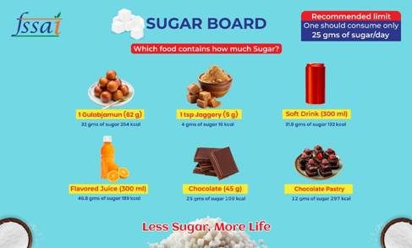Shri Nadda urged all stakeholders to respond to the Prime Minister's clarion call and reduce oil consumption by 10% and reduce salt intake that can be ensured through awareness towards right food habits. He also commended the innovative behavioural change strategy i.e., the widespread promotion of Sugar and Oil Boards across schools, workplaces and public institutions, developed by FSSAI under the aegis of Union Ministry of Health & Family Welfare that serve as powerful visual advocacy tools, displaying clear, relatable information about hidden sugars and fats in everyday food items. By embedding these messages in common spaces- canteens, corridors, meeting rooms, they subtly nudge individuals to make healthier choices. He also suggested that to make the initiative more effective, calories intake should also be highlighted along with sugar and urged for incorporating awareness in the curriculum.

Emphasizing the importance of traditional foods, Shri Nadda urged all to “go for traditional foods that include foods like millets and revive them to ensure health for all.” He further highlighted the importance of informed choices and lifestyle changes and remarked that food safety habits are a continuous process that needs to be made a part of our lives and turned into a movement to 'eat right' while adhering to food safety norms.”

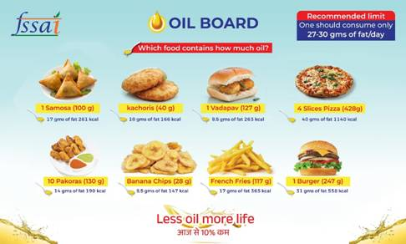During her special address, Ms. Punya Salila Srivastava, Secretary, Ministry of Health and Family Welfare emphasized the importance of early sensitization and collaborative inter-sectoral action to build a culture of safe food and healthy living. The Secretary highlighted the efforts for leveraging science, bringing surveillance and risk assessment systems to ensure safe and secure food for all. She also underlined the importance of healthy food habits and urged all the stakeholders to be vigilant and informed about food safety and avoid foods with harmful additives. She emphasized that “the Prime Minister's call for reducing oil consumption to stop obesity is not just a slogan, but a clarion call to adopt healthy dietary habits.” She further added that “to make India free of non-communicable diseases (NCDs), it is important to eat right and eat healthy, reduce oil intake and spread the message of healthy dietary habits through united efforts of all stakeholders. Healthy food choice is not just a personal cause, but also a contribution to the cause of healthy country.”

Shri Sanjay Kumar, Secretary, Department of School Education and Literacy, Government of India, emphasized on the importance of eating right and stopping obesity. He reiterated the Prime Minister's call for reducing oil consumption by 10% while emphasizing on the need to make children aware about their food choices and stressed on the need of community participation to ensure healthy eating habits. He also emphasized on the importance of good and right food on cognitive functions and highlighted the initiatives undertaken by the Department of School Education like incorporating Shri Anna (millets) in meals, emphasis on physical education and wellbeing to ensure healthy food habits amongst all students and teachers.

The event featured the launch of the Awareness Initiative to Stop Obesity, under FSSAI’s flagship Eat Right India programme. Drawing inspiration from the Hon’ble Prime Minister’s consistent emphasis on addressing the rising incidence of obesity in the country, the initiative aims to raise nationwide awareness about the health risks associated with obesity and non-communicable diseases. To ensure greater inclusivity and outreach, communication materials under this initiative are being developed in sign language as well as various regional languages. With a strategic mix of media outreach—including FM radio, railway audio announcements and digital platforms—the initiative seeks to build a mass movement for better nutrition and improved public health. As part of this material, a video featuring renowned chef Ranveer Brar extending his support towards Stop Obesity Campaign and urging people to reduce oil consumption was also released at the event.

The ‘Eat Right Activity Book– Your Guide to Eat Right at School’, a key resource under the Eat Right School initiative was also launched during the event. Designed to promote awareness of food safety, hygiene, and nutrition among school children, the book features engaging, age-appropriate activities across primary, middle, and high school levels. Developed by leading experts, it supports both curricular and extracurricular learning and empowers children to become early advocates for healthy eating within their schools and families.

The event was virtually attended by Shri Rajeev Bahl, Director General of the Indian Council of Medical Research (ICMR) and Secretary of the Department of Health Research (DHR), Government of India; G Kamala Vardhana Rao, CEO, FSSAI; Shri Sanjay Kumar, Secretary, Department of School Education and Literacy, Government of India, Shri Satish Kumar, Chairperson Railway Board, Chairperson CBSE, Shri Rahul Singh; senior officials of Government of India; Health Secretaries of States of Karnataka, Jharkhand, Madhya Pradesh and Chandigarh; Food Safety Commissioners of all States/UTs, members of Scientific Committee and Scientific Panels, FSSAI, Food Business Operators across the country, Industry Associations, Development Partners, Employees of FSSAI and State FDAs across the country.

**Source: Press Information Bureau, Press Release, 7 June 2025**

## India witnesses a steady downward trend in maternal and child mortality towards achievement of SDG 2030 targets

As per the Sample Registration System (SRS) Report 2021 released by the Registrar General of India (RGI), on 07th May, 2025, India has continued to witness a significant improvement in key maternal and child health indicators.

As per the Special Bulletin on Maternal Mortality in India, 2019-21 based on the Sample Registration System (SRS), the Maternal Mortality Ratio (MMR) of the country has shown a marked reduction, declining by 37 points from 130 per lakh live births in 2014–16 to 93 in 2019–21.

Similarly, as per the Sample Registration System Statistical Report 2021, the downward trend of child mortality indicators continued. The Infant Mortality Rate (IMR) of the country has declined from 39 per 1000 live births in 2014 to 27 per 1000 live births in 2021. Neonatal Mortality Rate (NMR)has declined from 26 per 1000 live births in 2014 to 19 per 1000 live births in 2021. Under-Five Mortality Rate (U5MR) has declined from 45 per 1000 live births in 2014 to 31 per 1000 live births in 2021. The Sex Ratio at Birth improves from 899 in 2014 to 913 in 2021. Total Fertility Rate is consistent at 2.0 in 2021, which is a significant improvement from 2.3 in 2014. As per SRS 2021 Report:

* Eight (8) States have already attained SDG target of MMR (<=70 by 2030): Kerala (20), Maharashtra (38), Telangana (45), Andhra Pradesh (46), Tamil Nadu (49), Jharkhand (51), Gujarat (53), Karnataka (63).
* Twelve (12) States/UT have already attained SDG target of U5MR (<=25 by 2030): Kerala (8), Delhi (14), Tamil Nadu (14), Jammu & Kashmir (16), Maharashtra (16), West Bengal (20), Karnataka (21), Punjab (22), Telangana (22), Himachal Pradesh (23), Andhra Pradesh (24) and Gujarat (24).
* Six (6) States/ UT have already attained SDG target of NMR (<=12 by 2030): Kerala (4), Delhi (8), Tamil Nadu (9), Maharashtra (11), Jammu & Kashmir (12) and Himachal Pradesh (12).

## Further, India's Progress in reduction of Maternal and Child mortality indicators outpaces Global Averages. As per the current United Nation Maternal Mortality Estimation Inter-agency Group (UN-MMEIG) Report 2000-2023, published on 07 April 2025, India’s MMR has reduced by 23 points from 2020 to 2023.  By this achievement, MMR of India has now declined by 86% compared to global reduction of 48% over the past 33 years from 1990 to 2023.

Significant achievement has been highlighted in reduction of Child Mortality in India in the United Nations Inter-agency Group for Child Mortality Estimation (UN IGME) Report 2024, published on 24 March, 2025. India is among the top performer countries with reduction in Child Mortality Rates. As per the Report, India achieved a 78% decline in the Under-Five Mortality Rate (U5MR) surpassing the global reduction of 61%; 70% decline in the Neonatal Mortality Rate (NMR) compared to 54% globally, and 71% decline in the Infant Mortality Rate (IMR) compared to 58% globally, over the past 33 years from 1990 to 2023.

**These sustained improvements are a result of strategic interventions and unwavering commitment of the Government of India.**

The Government’s flagship health schemes are seamlessly integrated to guarantee dignified, respectful, and high-quality healthcare services—completely free of cost, with zero tolerance for denial of care. Ayushman Bharat, the world’s largest health assurance initiative, provides an annual health coverage of up to ₹5 lakh per family, ensuring financial protection and access to essential services.

Focused interventions ensure that every pregnant woman is entitled to free institutional delivery, including caesarean sections, along with complimentary transport, medication, diagnostics, and nutrition support in public health facilities. To ensure inclusive and equitable access, the Ministry has significantly strengthened health infrastructure by establishing Maternity Waiting Homes, Maternal and Child Health (MCH) Wings, Obstetric High Dependency Units (HDUs)/Intensive Care Units (ICUs) Newborn Stabilization Units (NBSUs), Sick Newborn Care Units (SNCUs), Mother-Newborn Care Units, and dedicated programs for the screening of birth defects.

Key clinical practices such as the administration of antenatal corticosteroids for preterm labor, use of Continuous Positive Airway Pressure (CPAP), and structured follow-up for hearing and vision screening contribute to improved newborn survival outcomes. These measures support approximately 300 lakh safe pregnancies and 260 lakh healthy live births annually.

A core priority is ensuring that quality healthcare services reach every corner of the country. This is being addressed through facility-based quality certification, enhancement of healthcare workers’ skills, and robust supervisory mechanisms. Special emphasis is placed on training and deploying skilled birth attendants, midwives, and community health workers to deliver essential maternal and child health services.

The Ministry is also reinforcing health data systems and real-time surveillance for maternal, newborn, and child health through digital platforms, thereby facilitating data-driven, evidence-based policy decisions.

**Source: SRS Report 2021/10May2025/PIB**

*We solicit your feedback:*

*Editing and Compilation by: Archana Saxena, JTA; IT support: Mohit Dhonkeriya;*

*Mentored by: Dr Bharti Sharma, Faculty-Gynaecology, SIHFW*

State Institute of Health & Family Welfare

Jhalana Institutional Area, South of Doordarshan Kendra Jaipur (Raj)

Phone-2706534

E-mail:-sihfwraj@ymail.com; Website: www.sihfwrajasthan.com